28/12/2021

REPORT OF THE 2021 GENERAL ASSEMBLY

Moral report, title of representatives
Observations
The committee were very pleased by The Charity WEBSITE
ACTIVITIES AND REPORT BY COUNTRY AND RESOLUTIONS
Is important to highlight that all our activities in different countries were Unanimously agreed my all members.

BORDEAUX FRANCE
Organise a Launching and Fundraising concert
Theme of the day
CARE FOR MIGRANTS AND CHILDRENS IN NEED OF BORDEAUX, MIGRANTS CHILDRENS FROM OTHERS PART OF THE WORLD SUCH AS UKRAINE AND PREGNANT REFUGEES WOMEN

VISIIT MIGRANTS CENTRE IN BORDEAUX
DONATE CLOTHES AND HYGIENE PRODUCT IN MIGRANT’S CENTRES IN BORDEAUX

BURKINA FASO
- Agriculture and Development
Report of Activities
The SHINE since 2019 had constantly witnesses through many events and video what dynamic women of Burkina Faso encounters daily. Women in Burkina Faso has sent us many videos and suggesting what they need to alleviate extreme poverty and early death.

THE SHINE HUMANITAIRE SINCE 2020 had decided together in the sensitive matter of women and development BY requested to our partners in Burkina Faso to provide a quote:
That highlight all materials
Allowing them to transform from artisanal and archaique agriculture to modernize type for sustainable grow.
Set an Antena and charities shops in Burkina Faso.
RDC (REPUBLIC DEMOCRATIC OF CONGO)
THE VILLAGE HAS HOW MANY CHILDREN.
CLARIFICATION, how we ARE WE GOING TO HELP WITH the foods

Topic
FORCED MARRIAGE AND GIRLS MUTILATIONS

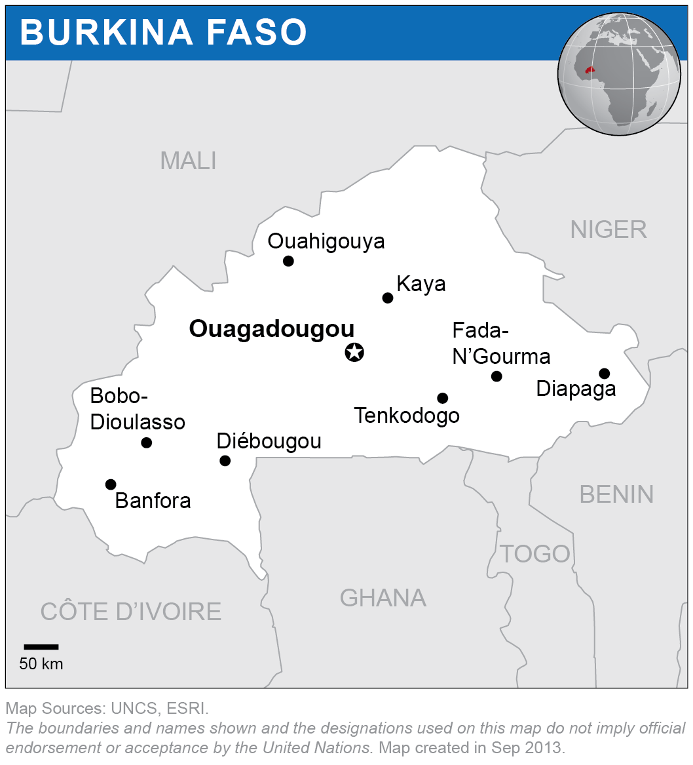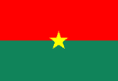

(Source. UN)
On Human Rights
According to UN statistics, women rights is violated in Burkina Faso. Women and girls suffering a gross violation of individual rights. Burkina Faso have 3 million child brides, 500, 000 married before reach age of 15. 3 million before age 18.
RESOLUTIONS
THE SHINE HUMANITAIRE had put into the community of Douma a program to monitor these issues very closely.
Programme and campaign on awareness of gross violation of children’s rights to end child marriage in Burkina Faso.
To be in collaboration with members of the community by campaigning against early marriage and girls’ mutilations
Speak to teachers and headteachers on the importance to include in the school curriculum lessons against early marriage and girl’s mutilations
THE SHINE HUMANITAIRE IN CAMPAGNING TO EMPOWER GIRLS AND WOMEN THAT THEY HAVE THE ABILITY USE THEIR POTENTIAL TOSUCCEED. We are planning to set programme for girls and women them to be pursuit happiness by going to school.

On Children’s Rights

In 2021 THE SHINE HUMANITAIRE DONATED STATIONARIES AND BOOKS IN SCHOOL.
THE SHINE HUMANITAIRE HAS SPOTTED ONE CHILD COMPLETELY NAKED DURING THE EVENTS OF THE DONATION.
RESOLUTIONS
THE SHINE HUMANITAIRE SPOKE TO THE MAYOR AND ASK THE MAYOR TO PURCHASE CLOTHES AND SHOES FOR THIS CHILD.
THE SHINE HUMANITAIRE WAS HAPPY AS THIS WAS DONE AND THE PICTURE OF THE CHILD IS THERE ON OUR WEBSITE
Education
Ensure equality for girls and boys in schools
Child labor
Campaigning against child labour, child exploitation and child prostitution On Women Rights
Agriculture and Development
Provide a motor culture material to women in agriculture for sustainable growth
RESOLUTION
PROVISIONAL REPORT APPLIANCES WAITING FOR QUOTATIONS.

RDC (Republic Democratic of Congo) (LUBUMBASHI)

Topic
CHILDREN’S RIGHTS AND HUMAN SECURITY

According to the statistic Relief web, RDC IN THE REGION OF LUBUMBASHI, Hunger and extreme poverty had hits many families. More than 20000 children are malnourished

CHILD MALNUTRITION

6 MONTHS TO 5 YEARS
RESOLUTION
Malnutrition, giving BABY MILK,
NUTRITION FOOD, MILK, FRUITS, SALADS
SURVEY TO FIND OUT WHAT TO DO TO STOP
CHILD MALNUTRITION
THE SHINE HUMANITAIRE PARTNER IN LUBUMBASHI HAD SUGGESTING TO THE SHINE HUMANITAIRE TO HELP WOMEN IN AGRICULTURE IN RDC
CHILDREN’S RIGHTS
HIGH RISK IN TEENS AND PREGNANCY / INTERVENTION IN CHILDREN'S ENVIRONMENTS, CONDOMS, PROGRAM ON THE IMPORTANCE OF EDUCATION IN GIRLS AND BOYS
SEMINARS. AWARENESS, Pamphlets in schools

DETAILS AND INFORMATION,
PREGNANCY, COACHING, LEARNING OF TRADES SURVEY ON SCHOOL AND GENDER EQUALITY IN RDC
than 20000 children are malnourished

Topic

Human Security and Health Security
Covid-19 Pandemic
Support children by providing them advice and the campaign on the management of the covid -19
Resolution
Distributing Masks, gloves, sanitizing gels, soaps.
Campaigning on vaccination in Lubumbashi
IVORY COAST
Childrens Rights
Education
In contact with an orphanage of 300 children and putting in place a project to donate stationaries, toys in the centre.

Cameroun
Women Rights
Agriculture and Development
Looking for the procedure of setting an Antena to help Women and girls in different parts of the country
Activity Report and resolutions
The committee unanimously
In France
Children’s Rights
In collaboration with the council to have different antenna in poor areas for campaigning against torture and better life conditions for young migrants
Agree to provide jumpers to child and migrants in different centre in France
Empower refugees in term of integration and inclusion in the hosting areas.
Set an Antenna and charities shops in France

Identify migrants’ personal needs and devotions by helping to organize different training such as football training, learning different languages.

HUMAN SECURITY and HUMAN RIGHTS
The committee unanimously agree to

Speak to businesses and write letters to provide excessive foods to limit food wastes.
We will also provide items of first necessities such as paracetamols, first aids, masks, lotions

In UK (UNITED KINGDOM)
Young Migrants
Fights for better life conditions in their hosting country, ensure they are fully integrating and not fill isolated in the community and the society as a whole

Covid-19 Pandemic

Visit to refugee’s centre and refugee’s councils in targeting areas

Visit strategic to Calais, date to be arranged.
BRASIL
We still collaborate and investigate UN statistics on child poverty in Brazil and child prostitution to organize a tangible project to tackle those issues.
HUMAN RIGHTS AND CLIMATE CHANGE
The UN Climate Change Conference (COP 26)

THE SHINE HUMANITAIRE WILL WRITE TO SCHOOLS, RAISE AWARENESS ON THE IMPORTANCE OF PROTECTING OUR PLANET.

ORGANISE A CAMPAIGN TO RAISE AWARENESS ON CLIMATE CHANGE IN DIFFRENTS COUNTRIES THAT WE ARE INVOLVED

Final point, based on different topics and resolutions unanimously taken
Total budget of THE SHINE HUMANTAIRE TO COMPLETE ITS ANNUAL PROJECT FOR 2022
IS £20 000

Provide a treasurer budget and also evaluate what we are about to achieved monthly.
Review our commitment by topics on human rights, children’s rights, human security, health security and woman rights to different countries we are involved with.

END AND CLOSING

